ROBOT SCARA

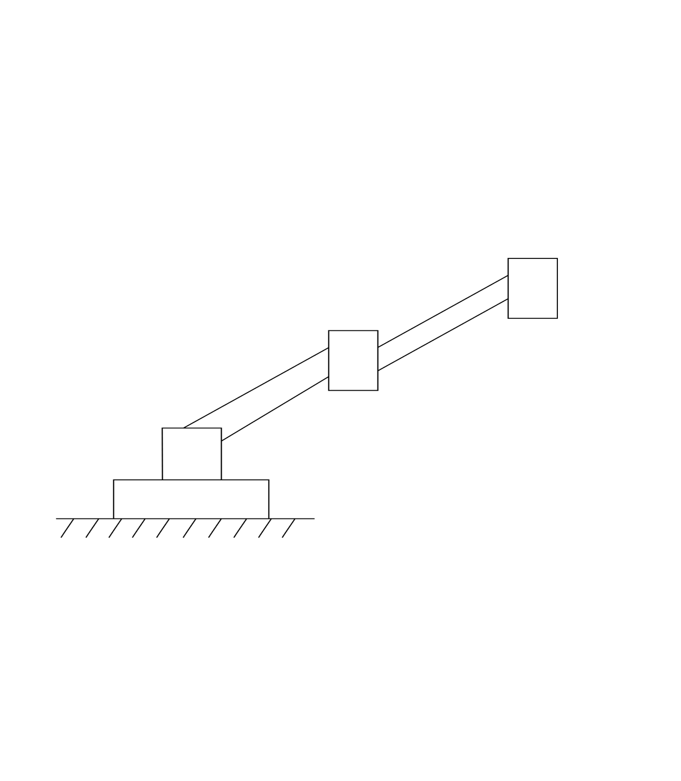

Parámetros DH

|  |  |  |  |  |
| --- | --- | --- | --- | --- |
| i | ai-1 | αi-1 | di | θi |
| 1 | 0 | 0 | 0 | θ1 |
| 2 | L1 | 0 | d2 | θ2 |
| 3 | L2 | 0 | d3 | θ2 |

Calculo de matrices homogéneas.

